Bampton and District Local History Society members’ meetings
Wrestlers, Crucks & Mullions
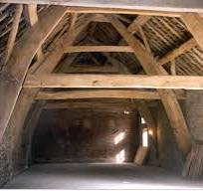
Cruck framing
Andy Lowe
Tuesday 1st April
7:30pm
Bampton Memorial Hall

Everyone welcome!
Refreshments will be served
Members £1 Visitors £3

